Entities

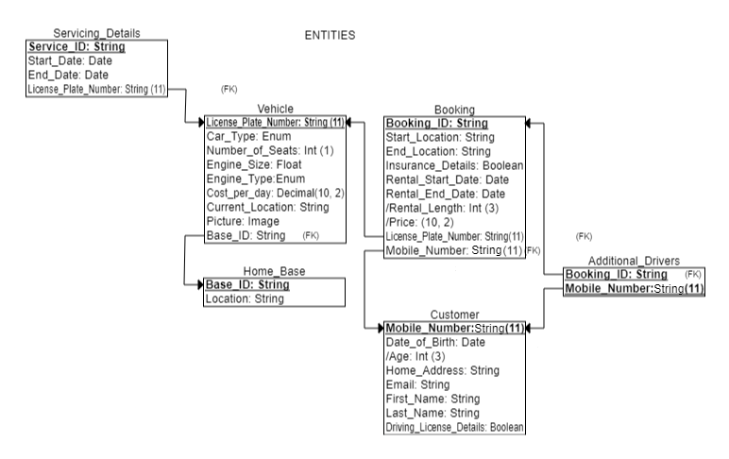

//Strong Entities

Vehicle (

License_Plate_Number: string (9), //PK

Car_Type: enum,

Number_of_Seats: integer (1),

Engine_Size: float,

Engine_Type: enum, //!!Auto/Manual enum!!

Cost_per_day: decimal (10, 2),

Current_Location: string (50),

Picture: binary object,

*Home_Base: string (50) //FK to Home_Base

)

Customer (

Mobile_Number: integer (11), //PK composite

Date_of_Birth: date, //PK composite

Age: integer (3), //derived from Date_of_Birth

Home_Address: string (50),

Email: string (50),

First_Name: string (50),

Last_Name: string (50),

Driving_License_Details: boolean

)

Home_Base (

Base_ID: string (50), //PK

Location: string (50)

)

//Weak Entities

Booking (

Booking_ID: string (50), //PK

Start_Location: string (50),

End_Location: string (50),

Insurance_Extras: boolean,

Rental_Start_Date: date,

Rental_End_Date: date,

Rental_Length: integer (3), //derived from Rental_Start_Date & //Rental_End_Date, min(1)

Price: decimal (10, 2), //derived from Vehicle.Cost_per_day & //Rental_Length

*License_Plate_Number: string (9), //FK to Vehicle

*Mobile_Number: integer (11) //FK to Customer

)

Additional_Drivers (

*Booking_ID: string (50), //FK to Booking & comp PK

*Mobile_Number: integer (11), //FK to Customer & comp PK

)

Servicing_Details (

Service_ID: string (50), //PK

Start_Date: date,

End_Date: date,

*License_Plate_Number: string (9) //FK to Vehicle

)

Attributes

Vehicle.Car_Type (

Small_Town_Car,

Family_Car,

MPY_7_seater,

Sports_Car,

Luxury,

Mini-Vans

)

Vehicle.Engine_Type (

Manual,

Automatic

)

Relationships

Vehicle-to-Servicing_Details (

One-to-Many from Vehicle-to-Servicing_Details,

License_Plate_Number FK in Servicing_Details table

reference License_Plate_Number PK in Vehicle

)

Vehicle-to-Booking (

One-to-Many from Vehicle-to-Booking,

License_Plate_Number FK in Booking table

references License_Plate_Number PK in Vehicle

)

Customer-to-Booking (

One-to-Many from Customer-to-Booking,

Mobile_Number FK in Booking table

references Mobile_Number PK in Customer

)

Vehicle-to-Home_Base (

One-to-Many from Vehicle-to-Home_Base,

Home_Base FK in Vehicle table

references Base_ID PK in Home_Base

)

Booking-to-Additional_Drivers (

One-to-Many from Booking-to-Additional_Drivers

Booking_ID FK in Additional_Drivers

references Booking_ID PK in Booking

)

Additional_Drivers-to-Customer (

One-to-One,

Mobile_Number FK in Additional_Drivers

References PK in Customer

)